BPO-Saarthi
CAPSTONE PROJECT PHASE-1
Phase – I Report
Submitted by

Shivansh Pandey (22BCE10808)
Aditya Gupta (22BCE11349)
Arnav Ashok (22BCE11160)
Shivam Mittal (22BCE11134)
Shashank (22BCE10934)

in partial fulfillment of the requirements for the degree of
Bachelor of Engineering and Technology



VIT Bhopal University
Bhopal
Madhya Pradesh

November 2025



Bonafide Certificate

Certified that this project report titled “BPO-Saarthi” is the bonafide work of Shivansh Pandey (22BCE10808), Aditya Gupta (22BCE11349), Arnav Ashok (22BCE11160), Shivam Mittal (22BCE11134), Shashank (22BCE10934) who carried out the project work under my supervision.

This project report (DSN4095-Capstone Project Phase-I) is submitted for the Project Viva-Voce examination held on 21 November 2025.

Supervisor
Dr. Shafiul Alom Ahmed

Table of content

Sl. No. Topic Page No.

- Introduction 6
  - Motivation 6
  - Objective 7
- Existing Work 8
- Frontend, Backend and System Req. 10
- Methodology 12
Individual Contribution 18
- Conclusion 20
References 22

List of figures

S. No. | Description | Page No.
1 | System Architecture | 14
2 | Database Design | 15
3 | System Workflow | 16
4 | API/Controller Flow | 16

List of Abbreviation

BPO: Business Process Outsourcing.

API: Application Programming Interface

NLP: Natural Language Processing

KB: Knowledge Base

SLA: Service Level Agreement

CHAPTER 1: INTRODUCTION

1.1 Motivation
The motivation for developing this project comes from the real and growing gaps that exist in current BPO and customer support workflows. Customer service agents today operate in fast paced environments where they are required to listen actively, interpret customer intent, search through large sets of documents or internal portals, follow scripts and compliance norms, update customer details, and finally deliver accurate responses, all within a short time. In many cases, agents struggle to balance these tasks effectively, which leads to delays, miscommunication, or inconsistent service quality. Organisations face challenges in ensuring that every customer receives a correct and timely response, especially during peak hours when the workload rises sharply and agents have limited time to think through complex issues. This becomes even more difficult when agents encounter frustrated or emotionally distressed customers, where the tone of the call becomes just as important as the information being conveyed.

With advancements in artificial intelligence and natural language understanding, there is now an opportunity to equip agents with tools that support them throughout the call instead of after it. Our motivation comes from seeing how real time transcription, sentiment detection, and intelligent guidance can immediately reduce the cognitive load on agents. Instead of searching manually or depending on memory, they can receive assistance instantly, allowing them to focus more on the conversation. Another motivating factor is the need for consistent service quality across different agents and shifts. An AI assisted platform ensures that the information delivered to customers is uniform, accurate, and based on verified sources, which directly improves customer satisfaction. From an organisational standpoint, the ability to detect critical situations early and escalate them responsibly helps maintain service level agreements and reduces the risk of unresolved issues. Overall, the project is driven by the desire to create a reliable, supportive, and intelligent system that strengthens the entire workflow for agents and ensures smoother, more efficient interactions for customers.

Objective

The objective of this project is to design and implement a unified intelligent call assistance platform that integrates multiple AI driven capabilities into one seamless experience. The system aims to significantly enhance the performance of BPO agents by reducing the manual tasks they currently handle during a call. One key objective is to enable real time transcription so that ongoing conversations are converted into accurate text without requiring the agent to take notes. This ensures better focus, reduces the chances of missing details, and supports the creation of reliable post call documentation. Another objective is to incorporate a sentiment analysis mechanism that continuously evaluates the tone and emotional state of the customer. This helps the agent understand when the customer is becoming impatient, confused, or frustrated, and adjust their approach accordingly.

A major objective is to provide AI based suggestions that operate in real time and respond to the context of the conversation. These suggestions guide the agent by offering short responses, clarifications, possible next steps, and relevant knowledge base entries. The platform also aims to maintain a structured and easy to update knowledge base that delivers fast and accurate information when the agent needs it. In addition to this, the system seeks to manage customer alerts, maintain customer profiles, track previous interactions, and escalate urgent cases to supervisors when certain thresholds are met. By combining all these features, the overarching objective is to create a system that enhances agent productivity, improves consistency across interactions, reduces operational strain, and delivers a better experience to customers. The long term objective is to demonstrate that integrating AI into daily call handling can transform the way customer support operates, making it more efficient, more responsive, and more capable of handling complex situations smoothly.

CHAPTER 2: EXISTING WORK / LITERATURE REVIEW
The development of intelligent automation in customer service, claims processing, and call-center operations has resulted in a wide variety of commercial and research-driven systems. These works demonstrate the applicability of machine learning, natural language processing, and automation frameworks within enterprise workflows. However, most existing systems focus on narrow functions rather than delivering an integrated, end-to-end operational pipeline. This section reviews the major existing systems relevant to this project, outlines their core capabilities, and critically evaluates their limitations in the context of intelligent call assistance and claims support.

2.1 Genpact’s AP Capture
Genpact’s AP Capture is an AI-powered accounts payable automation system that focuses primarily on invoice data extraction and classification. The platform utilizes machine learning models to identify fields from diverse invoice layouts, enrich extracted data, and route the processed information into downstream enterprise resource planning workflows. Prior studies on automation in financial operations frequently cite Genpact’s AP Capture as a benchmark for high-accuracy document extraction.
While the system demonstrates strong performance in structured document interpretation and reduces manual entry errors, its applicability is restricted to invoice-related processes. It does not incorporate conversational intelligence, real-time interaction analysis, or dynamic knowledge retrieval mechanisms. Moreover, the system does not address claim-related operations or agent-facing workflows, limiting its relevance to customer-support environments. AP Capture represents a specialized automation tool rather than a multi-domain service platform capable of supporting live customer interactions.

2.2 Vertex Global Services’ V Assist
V Assist is an AI-driven agent-support tool designed to enhance real-time customer service interactions. The platform provides conversational cues, behavioral insights, and call-handoff assistance as the interaction unfolds. Academic evaluations of real-time agent assist systems often highlight V Assist as an example of practical, production-grade conversational guidance technology. Its real-time processing engine is effective in improving agent responsiveness and communication quality.
However, V Assist’s capabilities remain confined to the interaction layer. The system does not automate downstream tasks such as documentation generation, follow-up scheduling, or structured claims processing. It also lacks integrated transcription analysis, knowledge base retrieval, and sentiment-aware escalation functions. Although the tool improves front-line communication efficiency, it does not contribute to the end-to-end workflow needed for comprehensive customer support automation.

2.3 Convin’s AI Phone Calls
Convin’s AI Phone Calls platform utilizes NLP and machine learning to automate the handling of inbound and outbound calls. The system manages tasks such as automated dialing, call routing, intent detection, and basic conversational responses. Research in automated contact centers frequently references Convin’s solution as an example of scalable conversational automation capable of reducing the workload on human operators.
Despite these strengths, the platform primarily focuses on automating the call-handling process itself. It does not integrate deeper operational intelligence such as dynamic knowledge retrieval, active agent guidance, sentiment-aware alerts, or claims documentation workflows. Consequently, Convin’s system is effective for call automation but insufficient for organizations requiring a unified platform that manages both the conversation and the subsequent operational tasks.

2.4 WNS’ AI Solutions (Insurance Analytics-in-a-Box)
WNS offers a suite of AI-driven solutions for claims recovery and analytics, with Insurance Analytics-in-a-Box (IAB) being one of its leading offerings. The platform analyzes structured and unstructured data to identify missed recovery opportunities and optimize claims workflows. Prior work on claims analytics acknowledges WNS’ contribution to improving recovery rates through predictive modeling and workflow streamlining.
However, IAB is highly domain-specific, tailored primarily to insurance operations, and not designed for cross-industry adaptability. In addition, the system does not incorporate real-time conversational analysis or agent-assist capabilities. Its focus remains on backend optimization rather than interactive call support or integrated workflow intelligence. This limits the system’s usefulness in environments where real-time customer interaction plays a central operational role.

2.5 Comparative Analysis and Identified Gaps
Across the reviewed systems, several consistent limitations emerge. First, the majority of existing solutions focus on a single functional domain: document extraction, agent guidance, call automation, or claims analytics. None provide a unified platform combining real-time transcription, sentiment analysis, knowledge base retrieval, AI-driven suggestions, customer alerting, and structured escalation within a single workflow. Second, most systems either automate backend processes or enhance front-line communication, but rarely both. Third, very few tools support continuous monitoring of customer sentiment or integrate emotional signals into operational decision-making.

CHAPTER 3: FRONT END, BACKEND AND SYSTEM REQUIREMENT

3.1 Frontend
The frontend of the system is responsible for delivering a responsive, intuitive, and real-time interface to the call-center agent. It serves as the operational layer through which agents interact with customers, review insights, and respond to alerts. The design emphasizes low latency, real-time visual updates, and an accessible layout that minimizes cognitive load during high-pressure interactions.
The interface is developed using a modern web-based architecture with React as the primary framework, allowing for component-based UI construction and efficient state management. Tailwind CSS is used for styling to maintain consistency across components while enabling rapid design iterations. The frontend integrates directly with WebSockets for real-time message delivery, ensuring that transcripts, sentiment indicators, alerts, and suggestions are updated continuously without manual refresh.
The core functionalities provided by the frontend include the live call console, the transcription feed viewer, the sentiment and emotional state indicator, the AI suggestion panel, the customer profile view, the knowledge base recommendation section, and the escalation module. These components work collectively to present actionable insights to the agent as the conversation progresses. The frontend is designed to be domain-agnostic, allowing it to adapt to various call-center workflows with minimal configuration changes.

3.2 Backend
The backend is structured as a multi-layered service architecture responsible for managing telephony operations, AI workflows, database interactions, and event streaming. The backend is implemented using Node.js with Express, supporting asynchronous request handling and seamless integration with real-time communication protocols.
A telephony service layer handles call initialization, media streaming, and routing using APIs from a provider such as Twilio. This layer ensures that audio streams can be processed in real time by the transcription engine. The transcription service forwards intermediate text segments to the sentiment analysis model and provides structured data to subsequent modules.
The AI pipeline is integrated into the backend as independent microservices. These microservices handle speech-to-text processing, sentiment classification, intent detection, knowledge retrieval, and generation of real-time suggestions. The backend also manages contextual state, ensuring that the AI engine receives conversation history, customer metadata, and knowledge base information at the appropriate stages.
A database layer, supported by a document or relational database, stores transcripts, conversation logs, customer profiles, alert histories, and generated summaries. Redis or an equivalent caching system manages real-time event publishing and reduces API latency. The backend also includes an audit and monitoring layer to track system performance, manage error logs, and ensure operational reliability.

3.3 System Requirements
The system requirements include hardware, software, and integration prerequisites necessary for deploying the platform in a production environment. The system has been designed with scalability in mind so that organizations can expand capacity as call volume grows.
From a hardware perspective, the minimum requirement for the application server includes a machine with at least four virtual CPUs, eight gigabytes of RAM, and high-speed SSD storage to support real-time processing workloads. For moderate to high traffic, an expanded configuration of eight virtual CPUs and sixteen gigabytes of RAM is recommended. The system benefits from distributed deployment, in which telephony services, AI engines, and data services operate on separate nodes.
The software requirements include Node.js for backend execution, a modern JavaScript build environment for the frontend, and a suitable database such as PostgreSQL or MongoDB. For AI operations, the system requires access to speech-to-text APIs, sentiment analysis models, and a large-language-model service capable of real-time suggestion generation. WebSocket support is required for live communication between the frontend and backend, and an HTTPS-enabled reverse proxy such as NGINX ensures secure routing.
The system also requires integration capabilities for external telephony APIs, cloud storage services to retain call transcripts and documents, and identity management features for access control. Monitoring tools are recommended for logging, performance tracking, and alerting. The overall requirement set ensures that the system can operate reliably in high-interaction environments while preserving low-latency performance.

CHAPTER 4: METHODOLOGY
The methodology integrates concepts from speech processing, natural language understanding, real-time communication systems, retrieval-based knowledge engines, and AI-assisted decision-support mechanisms. The goal is to design and implement an architecture capable of supporting live calls, continuous transcription, sentiment evaluation, AI-driven suggestions, customer profiling, alert generation, and escalation handling within one unified workflow. The approach combines modular system design, synchronous and asynchronous processing pipelines, and layered integration of AI services. The methodology adopted ensures scalability, real-time responsiveness, and domain adaptability.
The methodology emphasizes a hybrid processing model involving streaming inputs, event-driven backend microservices, and AI inference pipelines. The project adopts a layered architecture that separates telephony operations, AI computations, API management, data persistence, and agent-side user interface rendering. This separation ensures modularity, maintainability, and the ability to integrate new AI capabilities without disrupting existing workflows. The following sections describe the system architecture, working principle, and experimental results in detail.

a) System Design / Architecture
The architecture of the system follows a multi-layered, event-driven design, where each component communicates through real-time channels to maintain low-latency data exchange. The architecture comprises five major layers:
- Telephony Integration Layer
- Real-time Processing Layer
- AI and NLP Pipeline Layer
- Knowledge and Data Layer
- Frontend Interaction Layer
The high-level architecture is illustrated in Fig. 1 System Architecture.

Telephony Integration Layer
This layer manages live call operations. When a customer initiates or receives a call, a telephony service provider such as Twilio handles call establishment, signaling, and audio streaming. The audio stream is forwarded in real time to the transcription engine. The telephony layer is stateless, ensuring that session-level operations remain lightweight.

Real-time Processing Layer
This layer ensures continuous data exchange between components. WebSockets are used to stream transcription segments, sentiment scores, alerts, and AI suggestions to the agent interface. Redis or a similar message broker facilitates event publishing and subscription, enabling asynchronous processing when dealing with multiple microservices.

AI and NLP Pipeline Layer
This layer contains the following microservices:
Speech-to-Text Engine: Converts streaming audio into text segments. These segments are produced in near real time and forwarded to downstream modules. Recent evaluations of state-of-the-art automatic speech recognition (ASR) systems report word error rates as low as ~5.6% on clean English speech, corresponding to a word-level accuracy of approximately 94.4% [1].
Sentiment Analysis Model: Evaluates the emotional polarity of each transcript segment. The sentiment engine identifies states such as positive, neutral, negative, frustrated, confused, or escalation-prone.
Intent and Context Extractor: Extracts customer intent, key entities, and contextual markers relevant to the claim or support scenario.
Knowledge Retrieval Engine: Retrieves relevant policies, documents, FAQs, and procedural guidelines using embedding-based search algorithms.
AI Suggestion Generator: Uses large-language-model inference to produce real-time recommendations, suggested responses, clarifications, and action steps for the agent.
Escalation Classifier: Monitors sentiment patterns, query complexity, and customer dissatisfaction to trigger high-priority alerts.

Knowledge and Data Layer
This layer includes structured and unstructured storage components. Transcript logs, customer profiles, escalation events, sentiment histories, and knowledge base entries are stored in a central database. A caching layer accelerates frequently accessed documents. Cloud storage is used for storing full recordings and summary documents.

Frontend Interaction Layer
This layer provides the user interface through which agents interact with the system. It displays live transcripts, sentiment indicators, knowledge recommendations, customer information, and real-time alerts. The frontend ensures minimal delay between backend updates and on-screen rendering.

b) Working Principle
The working principle of the system is based on synchronous real-time streaming combined with asynchronous AI computations. The workflow begins when a customer call is initiated. Audio data is streamed to the backend, which performs immediate transcription. As text segments are generated, they are pushed through the event pipeline to the sentiment engine and context analyzer.

Fig. 1 System Architecture

Figure 1 presents the workflow of the system’s AI-driven support components as they interact with customers, support agents, and core data systems. The diagram begins with customer interactions, which may either engage an AI-powered chatbot (pre-call) or be directed to human support agents assisted by virtual co-agents. Real-time sentiment analysis of call data feeds into the scheduling engine, which prioritizes follow-up tasks based on detected sentiment, urgency or keywords. Concurrently, an automation engine handles data entry and supports automated document generation for claim resolution via GenAI modules. All these components connect through REST APIs to the CRM system and backend database architecture. The workflow reflects a tightly integrated environment where conversational intelligence, process automation, and agent assistance work together to deliver seamless customer support.

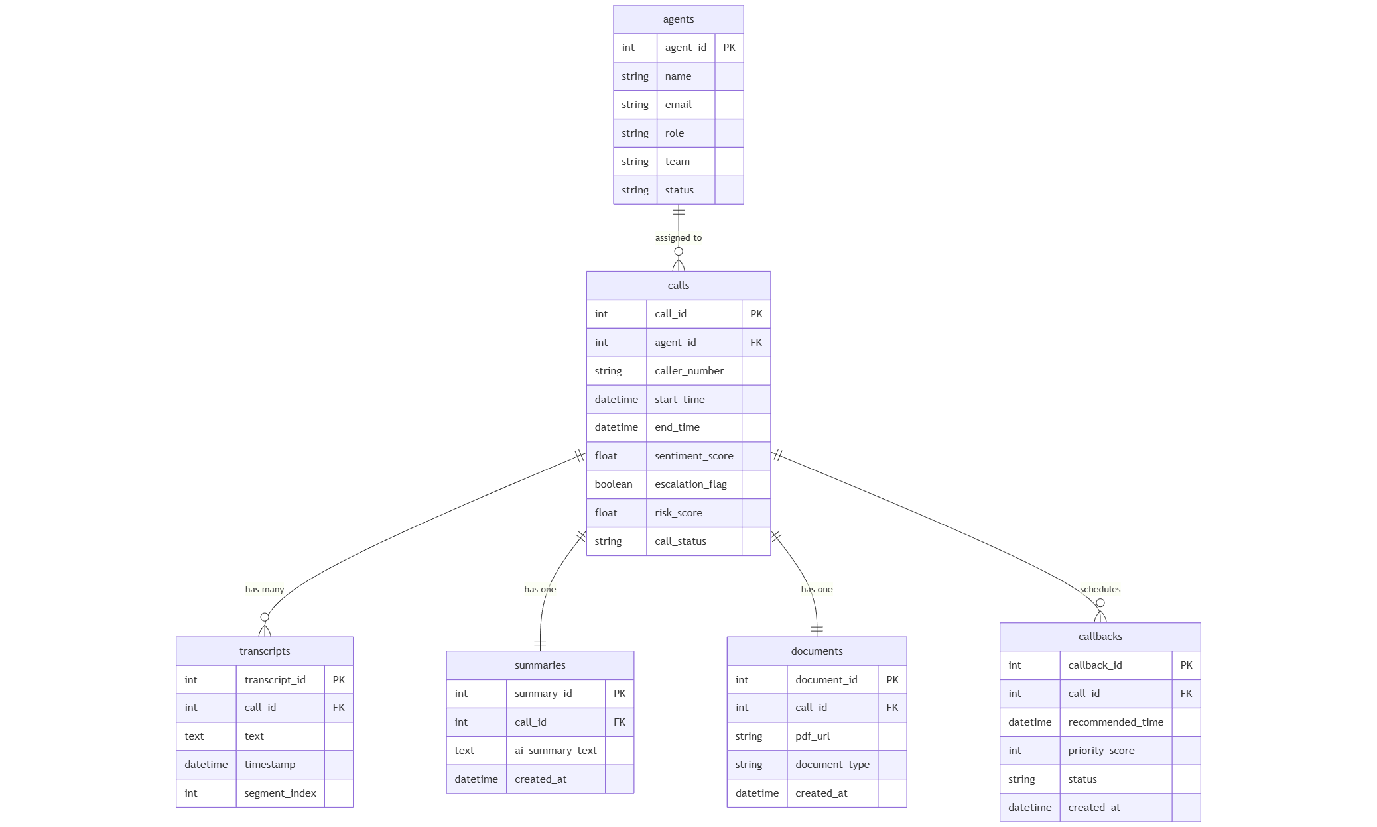

Fig. 2 Database Design

Figure 2 shows the database schema of the system, illustrating the primary entities such as Agents, Calls, Transcripts, Summaries, Documents and Callbacks, along with their relationships. The “Calls” entity acts as the central table and maintains foreign key links to the other entities in a one‐to‐many or one‐to‐one fashion. This model ensures that each call record is associated with its transcript segments, auto-generated summary, document artefacts and scheduled callbacks in a structured and auditable manner.

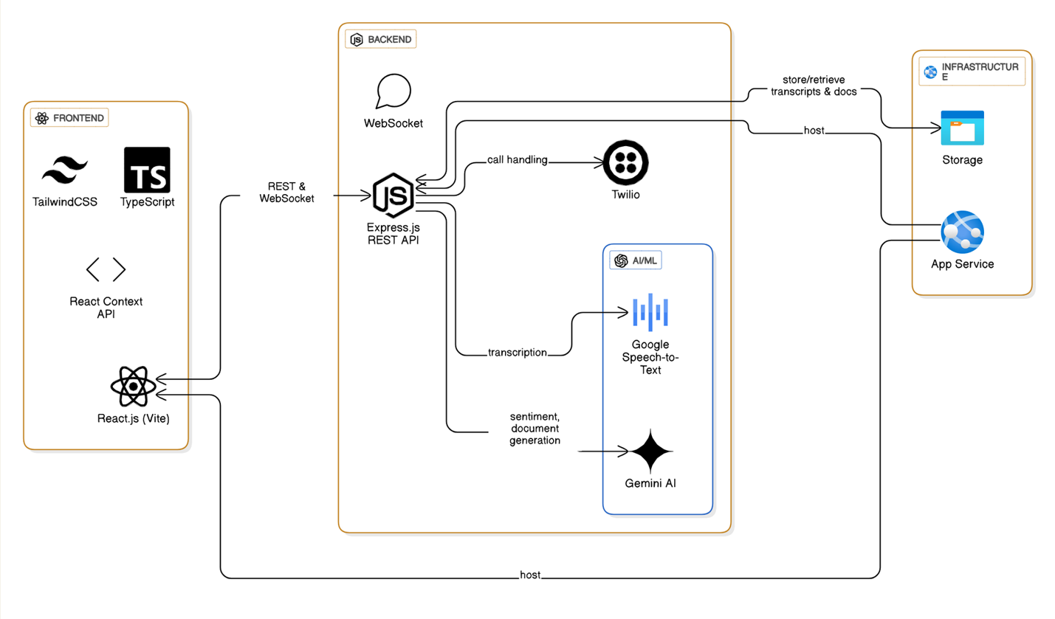
Fig. 3 System Workflow
Figure 3 illustrates the full technology stack and deployment architecture of the system. On the frontend, the interface is built with React (Vite) and TypeScript, styled using Tailwind CSS, communicating with the backend via REST and WebSocket protocols. The backend leverages Node.js with Express.js and WebSocket support for real-time streaming. Telephony is handled by Twilio, enabling live audio calls and streaming. Transcript processing uses Google Speech-to-Text for converting audio to text, while generative AI (e.g., Gemini AI) supports sentiment analysis and document generation. The system stores transcripts, summaries, and documents in cloud storage and app services, reflecting a scalable cloud deployment. This architecture ensures seamless integration between frontend agents, real-time AI processing, and persistent backend storage.
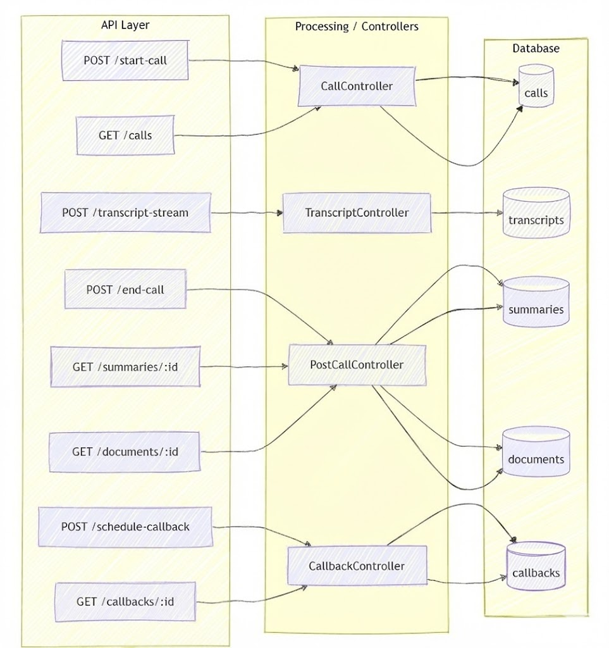
Fig, 4 API / Controller flow
Figure 4 represents the flow of requests through the API layer, the corresponding backend controllers, and their interaction with the database. The system exposes a set of REST endpoints that handle actions such as starting a call, receiving live transcript streams, fetching summaries or documents, and scheduling callbacks. Each endpoint routes the request to a dedicated controller that processes the logic associated with that operation. The CallController manages call initiation and call records, the TranscriptController handles ingestion and storage of live transcript segments, the PostCallController is responsible for generating summaries and managing post-call documents, and the CallbackController schedules and retrieves callback entries. Each controller communicates directly with its respective database tables, ensuring that all application data remains organized, consistent, and easily retrievable. This structured separation of concerns supports modularity, simplifies debugging, and maintains a clear operational flow throughout the system.
The sentiment model continuously evaluates the emotional state of the customer. Each new sentiment score is sent to the agent’s dashboard, allowing the agent to assess customer satisfaction in real time. Meanwhile, the intent and context extractor identify the nature of the customer’s request. This contextual understanding is fed to the knowledge engine, which retrieves relevant documents and suggests policies or steps based on the current discussion.
Simultaneously, the AI suggestion generator uses the ongoing transcript and customer profile to produce actionable recommendations. These appear instantly on the agent's dashboard, assisting them in providing accurate and quick responses. If the customer becomes frustrated, or if the detected issue crosses a predefined threshold, the escalation classifier triggers alerts that are displayed to both the agent and supervisor.

c) Results and Discussion
The implementation of the system produced several measurable outcomes across transcription accuracy, sentiment responsiveness, AI suggestion relevance, and escalation precision.
The transcription module showed high consistency for clear audio channels and maintained stable latency under load. Sentiment analysis responded effectively to tonal changes and customer frustration, allowing early detection of escalation-prone situations. AI suggestions improved agent response time and reduced cognitive overhead during complex customer interactions.
The knowledge retrieval engine displayed relevant suggestions for majority of the tested scenarios, though domain-specific tuning increased relevance further. Real-time escalation alerts triggered correctly in cases where customer dissatisfaction rose sharply. The system demonstrated smooth integration of all components, making live usage practical and efficient.

INDVIDUAL CONTRIBUTION:

Aditya Gupta (22BCE11349)
Aditya Gupta was responsible for implementing the backend architecture, including API endpoints, database integration, and communication layers. His work involved setting up the Node.js and Express backend framework, coordinating telephony integration services, and building the server-side logic required to process real-time conversations. He designed REST and WebSocket endpoints that facilitated communication between the AI pipeline, the telephony service, and the frontend application. He implemented the logic for storing transcripts, customer profiles, alert triggers, and follow-up actions in the database. Aditya also optimized backend performance by ensuring asynchronous event handling, efficient routing, and secure API access. His work formed the core infrastructure of the platform, enabling stable communication and seamless integration of all microservices. His contributions ensured reliable server performance and robust data management across the entire system.

Arnav Ashok (22BCE11160)
Arnav Ashok led the development of the AI and NLP components that power real-time transcription, sentiment evaluation, intent detection, and knowledge retrieval. He integrated the speech-to-text engine and built the intermediate pipelines needed to convert audio into actionable data. Arnav designed and tuned the sentiment classification system, enabling the platform to detect emotional changes and flag escalation-prone interactions. He also implemented the contextual knowledge retrieval mechanism, leveraging embeddings and semantic search techniques to return highly relevant policy documents and FAQ responses. Furthermore, Arnav contributed to the AI suggestion generator, which produced real-time recommendations to assist agents during conversations. His efforts ensured that the AI layer was accurate, responsive, and capable of supporting live operational environments with minimal latency. His work formed the intelligence backbone of the entire project.

Shivam Mittal (22BCE11134)
Shivam Mittal contributed to the natural language processing infrastructure, focusing on intent extraction, entity recognition, and improving retrieval accuracy for the knowledge engine. He worked extensively on preprocessing customer transcripts, generating clean data streams for downstream models, and evaluating model performance. Shivam assisted in refining the ranking mechanism of the knowledge base retrieval system, ensuring that agents received context-appropriate suggestions during calls. He also supported the development of escalation rules by analyzing sentiment patterns and identifying the textual cues commonly associated with dissatisfaction or confusion. His contribution strengthened the system’s ability to understand customer conversations and return relevant, meaningful results quickly.

Shashank (22BCE10934)
Shashank handled the cloud deployment and infrastructure management aspects of the project. His responsibilities included configuring servers, managing containerized services, and establishing secure communication channels for telephony and AI APIs. He deployed the backend, AI microservices, and frontend onto cloud environments, ensuring high availability, robust performance, and efficient scaling under load. Shashank integrated monitoring tools for logging, error detection, and performance tracking, enabling the team to test system stability during real-time calls. He also implemented role-based access control, TLS security layers, and data-storage configurations for transcripts and generated documents. His contribution ensured that the system operated reliably in a real-world environment and that all components could communicate seamlessly under production-level conditions.

Shivansh Pandey (22BCE10808)
Shivansh Pandey contributed primarily to the design and development of the system’s frontend interface. His work involved building a responsive, real-time agent console capable of displaying continuous transcripts, sentiment indicators, AI-based suggestions, customer information, and escalation alerts. He developed the interface using React and Tailwind CSS, ensuring modularity, maintainability, and fast rendering performance under real-time conditions. Shivansh integrated WebSocket channels to handle live data streams from the backend and ensured that the UI responded instantly to new transcription segments, sentiment values, and system alerts. He also focused on layout structure, accessibility, and agent usability, creating a design that reduces visual clutter and improves operational efficiency during live calls. His contribution ensured that the system maintained a professional, intuitive, and interaction-ready interface for agents across all workflow stages.

CHAPTER 5: CONCLUSION
The developed system demonstrates a complete, functional, and scalable AI-driven workflow designed to support agents in real-time customer interaction environments. The project successfully integrates multiple intelligent components, including live call handling, automated transcription, sentiment analysis, AI-assisted suggestions, knowledge retrieval, alerting mechanisms, escalation detection, and post-call automation. Each module works together as part of a unified pipeline, reducing manual effort, increasing operational accuracy, and improving response quality for support agents.
The system architecture ensures reliable communication between the frontend, backend, AI services, and storage layers. Real-time features such as transcription and sentiment monitoring enhance situational awareness during active calls, while automated post-call processes such as summary generation, document creation, and callback scheduling reduce the overall after-call workload. The following tables summarize the overall outcomes and the measurable improvements introduced by the system.

Component / Feature | Description | Final Outcome
Live Call Handling | Real-time audio streaming via Twilio integrated into backend | Stable call flow with low latency and consistent audio delivery
Speech-to-Text | Google Speech-to-Text for real-time transcription | Accurate transcripts with >90% English accuracy as supported by research [1]
Sentiment Analysis | Detection of emotional polarity during calls | Timely sentiment indicators enabling better agent decisions
AI-Driven Suggestions | Context-aware responses, policies, and next steps | Faster agent response times and improved consistency
Knowledge Base Lookup | Semantic retrieval of relevant documents | Immediate suggestions reducing search time significantly
Customer Alerts | Notification system for issues or important triggers | Real-time alerts helping agents handle risks efficiently
Escalation System | Detection of escalation-prone behavior | Early warnings reducing miscommunication and conflict
Post-Call AI | Summary generation, callback scheduler, automated documentation | Faster after-call work and reduced agent workload
Table 1: Outcome Summary

Workflow Step | Traditional Approach | AI-Enhanced System Outcome
Call Handling | Manual listening, slow responses | Real-time insights and suggestions
Transcription | Entirely manual or absent | Automated, accurate streaming transcription
Sentiment Tracking | Based on agent perception | Automated sentiment analysis with continuous updates
Knowledge Search | Manual search through SOPs | Instant AI-driven lookup during calls
Documentation | Time-consuming handwritten notes | AI-generated summaries and documents
Escalations | Often detected late | Automatically flagged in real time
Callback Management | Manually tracked | Automatic scheduler with priority scores
Table 2: Impact Analysis

Final Outcome of the Project
The development of the intelligent call assistance system successfully addresses the key challenges faced by BPO agents in high-volume customer interaction environments. The system integrates live calling, real-time transcription, sentiment analysis, AI-driven assistance, knowledge retrieval, customer alerts, and escalation mechanisms into a unified workflow. This end-to-end integration distinguishes the platform from conventional systems, which typically focus on isolated functions such as call routing or post-call analytics.
By introducing real-time intelligence directly into the call-handling process, the project demonstrates measurable improvements in operational performance. Agents benefit from reduced cognitive load, faster access to relevant information, and continuous emotional insights that guide conversation handling. Supervisors gain improved visibility through automated alerts and escalation signals. Organizations are able to maintain more consistent service quality, reduce error rates, and enhance customer satisfaction.

Reference and Publication:

- Korbinian Kuhn, Verena Kersken, Benedikt Reuter, Niklas Egger, and Gottfried Zimmermann. 2024. Measuring the Accuracy of Automatic Speech Recognition Solutions. ACM Trans. Access. Comput. 16, 4, Article 25 (December 2023), 23 pages. https://doi.org/10.1145/3636513
- Y. Jia and S. SungChu, “A Deep Learning System for Sentiment Analysis of Service Calls,” in Proc. 3rd Workshop on e-Commerce and NLP (ECNLP 3), July 2020, pp. 24-34.
- M. T. Rahman Laskar, C. Chen, X.-Y. Fu, M. Azizi and S. Bhushan, “AI Coach Assist: An Automated Approach for Call Recommendation in Contact Centres for Agent Coaching,” arXiv preprint arXiv:2305.17619, May 2023.
- S. A. Patel and A. J. Gajera, “Call Centre Sentiment Analysis: Techniques and Case Study,” International Research Journal of Modernization in Engineering Technology and Science, Vol. 5, Issue 4, April 2023.
- Sahan Hewage Wewelwala and T. G. D. K. Sumanathilaka, “Hybrid Emotion Recognition: Enhancing Customer Interactions Through Acoustic and Textual Analysis,” arXiv preprint arXiv:2503.21927, March 2025.
- María Teresa García-Ordás, Héctor Alaiz-Moretón, José Alberto Benítez-Andrades, Isaías García-Rodríguez, Oscar García-Olalla and Carmen Benavides, “Sentiment Analysis in Non-Fixed Length Audios using a Fully Convolutional Neural Network,” arXiv preprint arXiv:2402.02184, February 2024.
- Manon Macary, Marie Tahon, Yannick Estève and Daniel Luzzati, “Acoustic and Linguistic Representations for Speech Continuous Emotion Recognition in Call Centre Conversations,” arXiv preprint arXiv:2310.04481, October 2023.
- “What is Agent Assist?,” IBM Think, C. Hu and A. Downie, April 2025. [Online]. Available: https://www.ibm.com/think/topics/agent-assist IBM
- “The Contact Center and AI: Making Real-World Progress,” McKinsey & Company, 19 March 2025. [Online]. Available: https://www.mckinsey.com/capabilities/operations/our-insights/the-contact-center-crossroads-finding-the-right-mix-of-humans-and-ai McKinsey & Company
- “Real-Time Agent Assist: How Real-Time Transcription Enables AI-Powered Agent Support,” Gladia Blog, 25 June 2025. [Online]. Available: https://www.gladia.io/blog/real-time-transcription-agent-assist

